Cafeteria Sales Analysis
====================================================================================================
Executive Summary:
This Report represent the comprehensive of the Cafeteria Coffee shop sales data. The findings indicate that beverage items—especially coffee-based products—are the primary revenue drivers. Quantity sold has a strong positive impact on total revenue, while price sensitivity affects certain product categories.
Data Overview:
The dataset contains transactional- level sales records with the following columns:
- Date
- Item
- Quantity
- Price Per Unit ($)
- Total Spent ($)
Each row represents a customer purchase transaction.
Data Cleaning & Preparation:
- Remove the rows containing:
- “Error”
- “Unknown”
- Missing Values
- Converted the columns data types
- Date column converted in proper data format
- Quantity converted in integer
- Price per Unit and Total Spent converted in float
- Verified the calculation:
- Total Spent = Quantity *Price per unit
- Remove the duplicate record
Overall Business Performance
Key Metrics
- Total Revenue
Sum of Total Spent column
- Total Quantity Sold
Total number of items sold.
- Average Order Value
Total Revenue ÷ Total Transactions
- Average Price Per Item
Mean of Price Per Unit column
Best-Selling Items Analysis
Quantity-Based Ranking
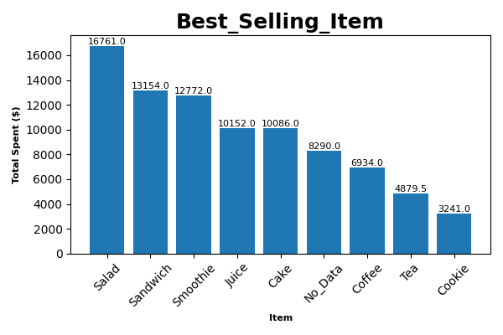

Using group-by analysis:
- Salad
- Tea
- Sandwich
- Cake
Insight:
Salad dominates in quantity sold, making it the core product of the cafeteria.
Revenue Contribution Analysis
Location Based Revenue
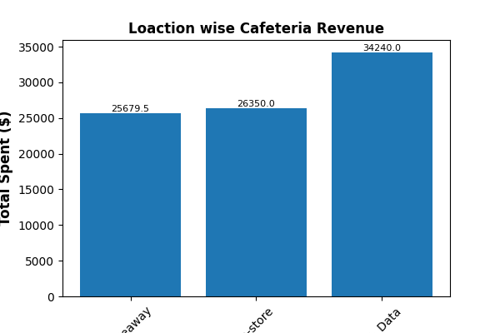
Most of the Locations have records provided and Most of the customers are purchasing the Instore
Top revenue contributors:
- No data provided
- Instore
- Take Away
Correlation Analysis
Correlation was calculated between:
Quantity
Price Per Unit
Total Spent
Results Interpretation
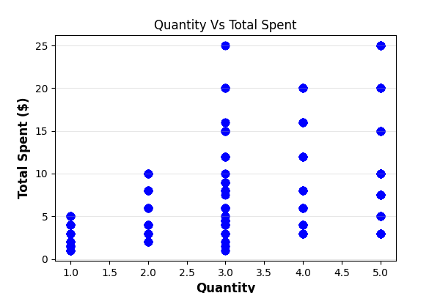
Quantity vs Total Spent → Strong Positive Correlation
Revenue increases significantly with higher quantity sold.
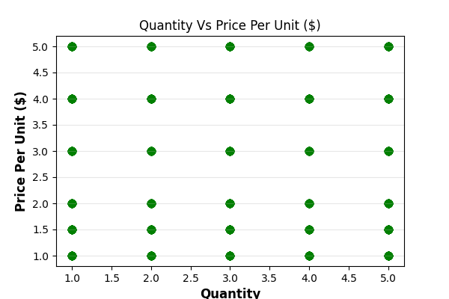
Price vs Quantity → Slight Negative Correlation
Higher price may slightly reduce demand.
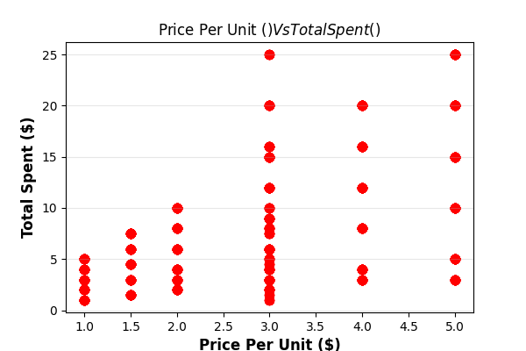
Price vs Total Spent → Moderate Positive Correlation
Expensive items contribute to revenue even if sold in smaller quantities.
Customer Behavior Analysis
Buying Pattern Observations:
- Customers prefer affordable daily-consumption items.
- Salad is the primary repeat-purchase item.
- Food items are often purchased along with beverages.
- Premium drinks attract fewer but higher-paying customers.
Business Recommendations
1. Focus on Star Products
Increase promotion of:
- Coffee
- Cookies
- Tea
Ensure no stock-outs.
2. Introduce Combo Offers
Examples:
- Coffee + Sandwich
- Tea
- Cold Coffee + Snacks
3. Price Optimization Strategy
- Slight increase in high-demand products.
- Offer discounts on slow-moving items.
4. Customer Loyalty Strategy
- Loyalty cards
- Buy 5 coffees, get 1 free
- Morning & evening special offers
5. Inventory Management
- Maintain higher stock of best-selling items.
- Reduce inventory for low-performing items.
Final Conclusion
The Cafeteria Coffee Shop is operating with:
- Strong beverage-driven sales
- Consistent revenue generation
- High correlation between quantity and revenue
- Clear top-performing products
The business shows stable performance with strong growth potential through:
- Strategic pricing
- Bundling offers
- Marketing optimization
- Data-driven inventory planning

